**SSN College of Engineering**

**Department of Computer Science and Engineering**

**UCS1512 – Microprocessors Lab**

**EX:10 – Display a String**

Exp No: 10 Name : Kshitij Sharma

Date: 15/10/2020 Reg No: 185001080

# Aim

To write a program to display a string in an 8086 microprocessor using MASM and DOSBox.

# Algorithm

1. Define the string in the data segment and make sure to terminate with “$”
2. Initialize the data segment register with a data segment address
3. Call the DOS Interrupt Function 21H with AH=9 after loading the effective address of the string message into DX
4. Terminate the program by calling the DOS Interrupt Function 21H with AH = 4CH

# Program to display a string

|  |  |
| --- | --- |
| **Program** | **Comments** |
| START:  MOV AX,DATA MOV DS,AX | Initializing the data segment register with the data segment address |
| MOV AH,9  LEA DX, MESSAGE INT 21H | Calling the DOS Interrupt Function 21H with AH=9 after loading the effective address of the string message into DX |
| MOV Ah,4CH INT 21H CODE ENDS  END START | Calling the DOS Interrupt Function 21H with AH = 4CH to terminate the program |

**Snapshot:**

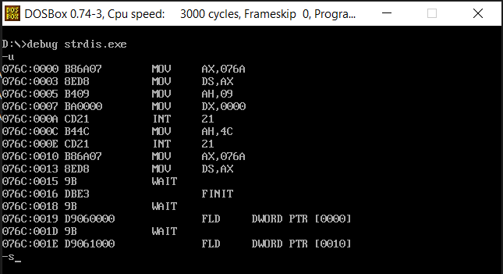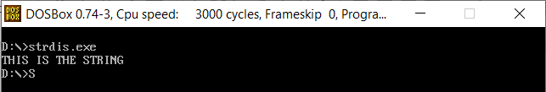

**Result**

Program for performing case conversion on the fly in an 8086 microprocessor using MASM and DOSBox was implemented and the output was verified.